Golf Rain Cover Manufacturers
Item No. | TH-GC09
Material | Nylon with Waterproof
Brand | OEM/Customer's design is welcomed
Logo | Printed
Feature | - Could protect any kinds of bags in raning day or Sunny day  2.With three buckles which could protect bags very well  3. Could add any value package for value things  4.Pack into a small bag, easier for you to carry with
Package | Packing: 1pc/PE bag,125pcs/ CTN
 | Carton Size: 54*54*57cm; G.W.:61.5KGS
Lead Time | Sample: 2-3 weeks with logo
 | Order: 4-5 weeks after order confirmed

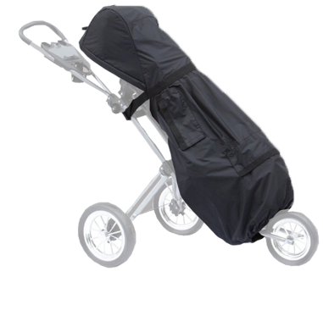

Packaging Detail:

1pc/PE bag,125pcs/ CTN
Carton Size: 54*54*57cm; G.W.:61.5KGS

Company Information:

1998---A family business, a golf bag workshop, was founded, focusing on the local Chinese market.
2005---Moved to new 5000 square meter factory, employing 200 workers, with a production capability,
to produce 5000pcs per month.
2006---TH-SPORT (H.K.) was established, started to export our products world wide.
2008---Became partners with Grip, Glove, Cap & Umbrella factories.
2009---Started doing business with, Maxfli, Mercedes-Benz, Jaguar, Cleveland,Tommy Armour, Dunlop,
Hippo, Hello Kitty,Yamamoto, Ecco and a range of smaller companies.
2010---Opened a show room, to display all we have, on the pretty

